

Отчёт по УП 02.01

Выполнил студент:

Михайлов Д.А.

Группа: П2-18

Преподаватель:

Тулупов А.В.

Королев 2021

Содержание отчёта

**Раздел 1. Разработка калькулятора** 3

Разработка калькулятора 3

**Раздел 1. Разработка калькулятора** 4

**To-Do List** 7

**Заключение** 8

**Приложение** 9

# **Раздел 1. Разработка калькулятора**

from tkinter import *

class Main(Frame):

def __init__(self, root):

super(Main, self).__init__(root)

self.build()

def build(self):

self.formula = "0"

self.lbl = Label(text=self.formula, bg="#000", foreground="#FFF")

self.lbl.place(x=11, y=50)

btns = [

"+", "-", "*", "/",

"1", "2", "3", "DEL",

"4", "5", "6", "C",

"7", "8", "9", "=",

"0", "(", ")"

]

x = 10

y = 140

for bt in btns:

com = lambda x=bt: self.logicalc(x)

Button(text=bt, bg="#FFF",

font=("Times New Roman", 15),

command=com).place(x=x, y=y,

width=115,

height=79)

x += 117

if x > 400:

x = 10

y += 81

def logicalc(self, operation):

if operation == "C":

self.formula = ""

elif operation == "DEL":

self.formula = self.formula[0:-1]

elif operation == "=":

self.formula = str(eval(self.formula))

else:

if self.formula == "0":

self.formula = ""

self.formula += operation

self.update()

def update(self):

if self.formula == "":

self.formula = "0"

self.lbl.configure(text=self.formula)

if __name__ == '__main__':

root = Tk()

root["bg"] = "#000"

root.geometry("485x550+200+200")

root.title("Калькулятор")

root.resizable(False, False)

app = Main(root)

app.pack()

root.mainloop()

# **Раздел 1. Разработка блокнота**

import os

from tkinter import Tk, Text, Menu, Scrollbar, N, S, E, W, RIGHT, Y, END

from tkinter.messagebox import showinfo

from tkinter.filedialog import asksaveasfilename, askopenfilename

class RightClicker:

def __init__(self, event):

right_click_menu = Menu(None, tearoff=0, takefocus=0)

for txt in ['Cut', 'Copy', 'Paste']:

right_click_menu.add_command(

label=txt, command=lambda event=event, text=txt:

self.right_click_command(event, text))

right_click_menu.tk_popup(event.x_root, event.y_root, entry='0')

def right_click_command(self, event, cmd):

event.widget.event_generate(f'<<{cmd}>>')

class Notepad:

def __init__(self, **kwargs):

self.file_name = None

self.root = Tk()

self.root.title("Untitled - Notepad")

self.text_area = Text(self.root)

menu_bar = Menu(self.root)

file_menu = Menu(menu_bar, tearoff=0)

edit_menu = Menu(menu_bar, tearoff=0)

help_menu = Menu(menu_bar, tearoff=0)

self.root.config(menu=menu_bar)

scrollbar = Scrollbar(self.text_area)

scrollbar.pack(side=RIGHT, fill=Y)

scrollbar.config(command=self.text_area.yview)

self.text_area.config(yscrollcommand=scrollbar.set)

self.text_area.bind('<Button-3>', RightClicker)

# set icon and window size (default is 300 x 300)

try:

self.root.wm_iconbitmap("Notepad.ico")

except: #pylint: disable=W0702

pass

try:

width = kwargs['width']

except KeyError:

width = 300

try:

height = kwargs['height']

except KeyError:

height = 300

# place notepad in the center of the screen

screen_width = self.root.winfo_screenwidth()

screen_height = self.root.winfo_screenheight()

left = (screen_width / 2) - (width / 2)

top = (screen_height / 2) - (height / 2)

self.root.geometry('%dx%d+%d+%d' % (width, height, left, top))

self.root.grid_rowconfigure(0, weight=1)

self.root.grid_columnconfigure(0, weight=1)

self.text_area.grid(sticky=N + E + S + W)

# file menu controls

file_menu.add_command(label="New", command=self.new_file)

file_menu.add_command(label="Open", command=self.open_file)

file_menu.add_command(label="Save", command=self.save_file)

file_menu.add_separator()

file_menu.add_command(label="Exit", command=self.quit_application)

menu_bar.add_cascade(label="File", menu=file_menu)

# edit menu controls

edit_menu.add_command(label="Cut", command=self.cut_text)

edit_menu.add_command(label="Copy", command=self.copy_text)

edit_menu.add_command(label="Paste", command=self.paste_text)

menu_bar.add_cascade(label="Edit", menu=edit_menu)

# help menu controls

help_menu.add_command(label="About Notepad", command=self.show_about)

menu_bar.add_cascade(label="Help", menu=help_menu)

def quit_application(self):

self.root.destroy()

def show_about(self):

showinfo("Notepad", "Mrinal Verma")

def open_file(self):

self.file_name = askopenfilename(

defaultextension=".txt",

filetypes=[("All Files", "*.*"), ("Text Documents", "*.txt")])

if self.file_name == "":

self.file_name = None

else:

self.root.title(os.path.basename(self.file_name) + " - Notepad")

self.text_area.delete(1.0, END)

with open(self.file_name, 'r') as file:

self.text_area.insert(1.0, file.read())

def new_file(self):

self.root.title("Untitled - Notepad")

self.file_name = None

self.text_area.delete(1.0, END)

def save_file(self):

if self.file_name is None:

self.file_name = asksaveasfilename(

initialfile='Untitled.txt', defaultextension=".txt",

filetypes=[("All Files", "*.*"), ("Text Documents", "*.txt")])

if self.file_name == "":

self.file_name = None

else:

with open(self.file_name, 'w') as file:

file.write(self.text_area.get(1.0, END))

self.root.title(os.path.basename(self.file_name) + " - Notepad")

else:

with open(self.file_name, 'w') as file:

file.write(self.text_area.get(1.0, END))

def cut_text(self):

self.text_area.event_generate("<<Cut>>")

def copy_text(self):

self.text_area.event_generate("<<Copy>>")

def paste_text(self):

self.text_area.event_generate("<<Paste>>")

def run_notepad(self):

self.root.mainloop()

def main():

notepad = Notepad(width=800, height=600)

notepad.run_notepad()

if __name__ == '__main__':

main()

# **To-Do List**

* Провести рефакторинг кода

# **Заключение**

Данные программы были разработаны для использования в учебных целях изучения языка Python.

**Приложение**

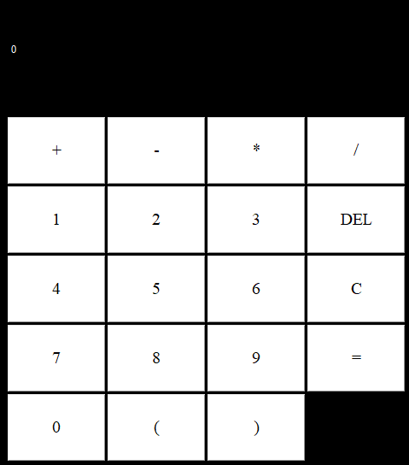

**Рисунок 1**

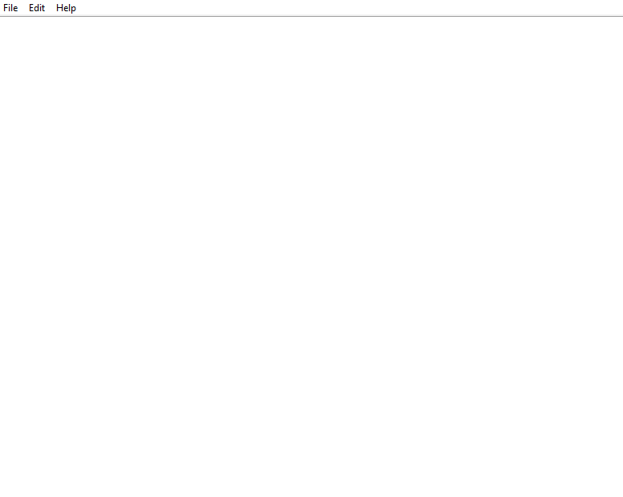

**Рисунок 2**

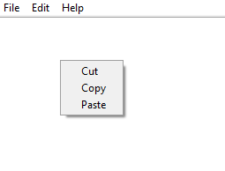

**Рисунок 3**